Test Number | Test Case Type | Description | Test Steps | Test Data | Expected Results | Actual Results | Status  (Pass/Fail)
1 | Database/  Functionality | Testing that sort codes generated for new accounts follow the required format standards (60-60-60, 60-60-70,60-70-70) | Create multiple accounts for same customer  Record generated sort codes  Verify format and uniqueness | Using existing customer profile “JOHN DOE” (CUST000002)  Create personal, ISA and business account  Record generated sort codes from each account creation | All sort codes should follow the same format: “60-xx-xx” where xx are numbers. Each account type should have appropriate prefix patterns:  Personal: 60-60-60  ISA: 60-60-70  Business: 60-70-70  Sort codes should be unique for each account | The program produced three accounts with the same format as expected with the appropriate patterns to distinguish account types. | Pass
2 | Consistency | Verify that sort codes maintain consistent formatting across all account displays and database storage | Use existing accounts  View accounts from accounts portal  Verify database storage format | Using existing customer profile “JOHN DOE”  View account in accounts portal  Check database entry for account | Sort code should display consistently as “60-xx-xx” as per account type format with hyphens in all views:  Account list, account actions and database | The program displayed the correct format for each account type consistently throughout the account list, account actions and database | Pass
Testing Notes:
This section here is to provide description that gives clarity to any glaring issues that needs addressing, information not applicable for the table and useful advice needed.
Test Number 1
Step 1 | Using existing customer profile:
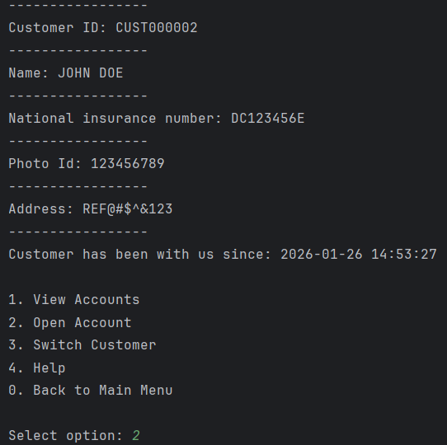
Step 2 | Create multiple accounts:
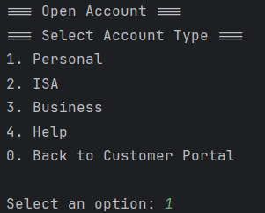
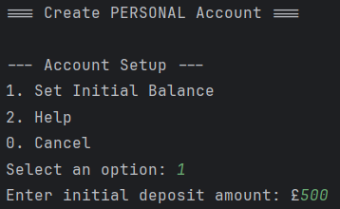
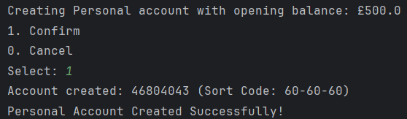
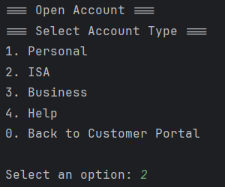
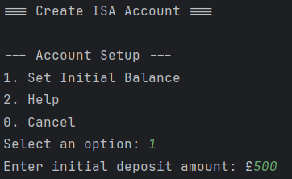
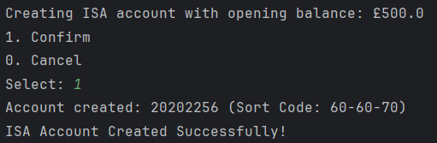
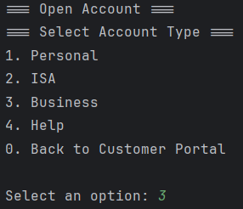
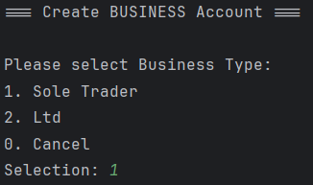
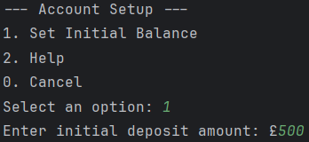
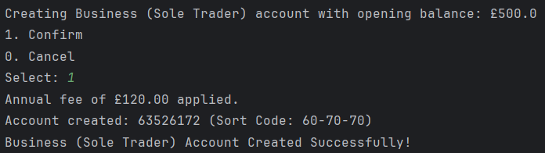
Step 3 | Record generated sort codes:
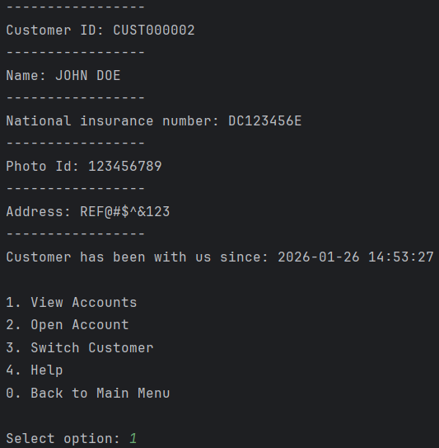
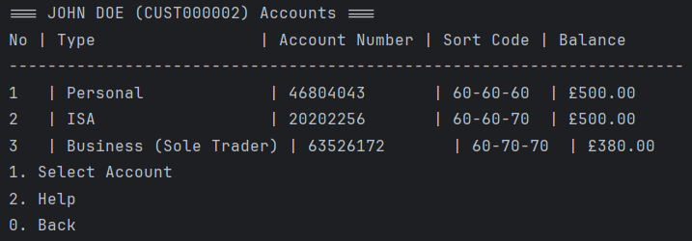
Test Number 2
Step 1 | Use existing accounts:
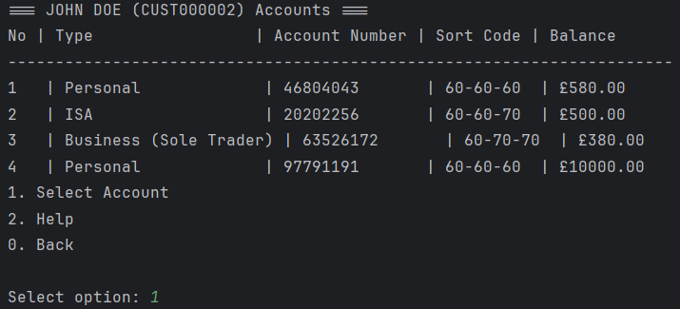
Step 2 | View accounts from accounts portal:
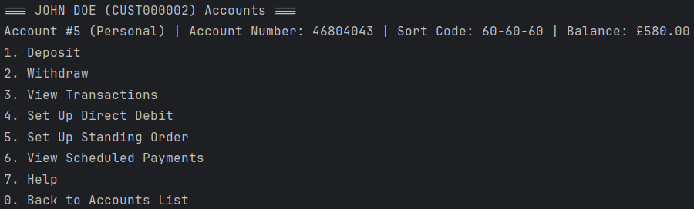
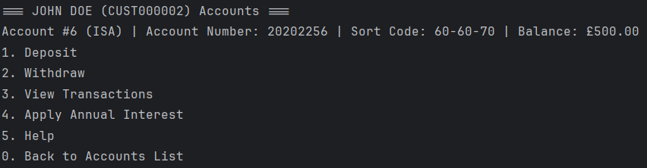
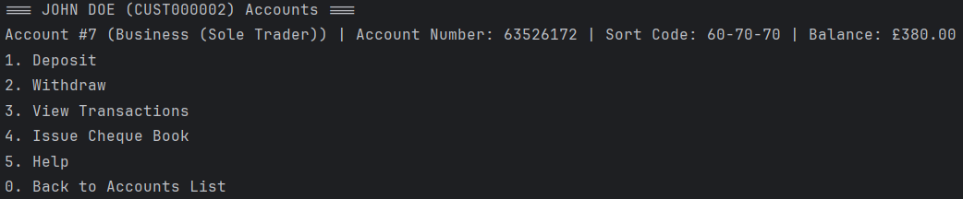
Step 3 | Verify database storage format:
